16 May 2002

Us & Them
25 May - 25 August 2002

The Great Eastern Hotel announces the latest in a series of exhibitions confirming it’s position as a major art venue in the City.

In a unique collaboration between the Great Eastern Hotel and curator Jaime Ritchie, artists were invited to stay for a weekend at the hotel and then create site specific work inspired by the space, architecture and life of the hotel. Visitors will encounter pieces throughout the building - from the main lobby to guest bedrooms - which draw on the theme of the dual identity of the East End of London as both a dynamic financial centre and home to 10,000 artists.

The fifteen artists of Us & Them include graduates from Goldsmith’s College, The Slade School of Art and the Royal College of Art, many of whom have been widely exhibited in prestigious international venues during the past few years but are in the exciting phase between graduation and widespread recognition. In London alone, they have appeared in shows at Camden Arts Centre, the Lisson Gallery, the Whitechapel Art Gallery and Saatchi Galleries, and the ICA, where Mark Hosking took part in City Racing last year. His brother, Paul, was recently a finalist in Becks Futures 3.

Visitors entering the Great Eastern will see Tim Hutchinson’s striking picture of a sleeping girl, and Paul Hosking’s reconstruction of a Wassily chair. They may also notice Andrew Miller and Duncan McAfee’s more discreetly placed replacement lobby clocks. Disabled gay artist David Lock’s painted images evoke a dreamy, distorted sensuality, and Glaswegian Ben Woodeson’s bizarre and slightly ominous sculptures made from old furniture will surprise unsuspecting guests. The hotel’s telephones will play specially commissioned on-hold music for the duration of the show.

Simon Willis, Director of Communications at the Hotel, says: ‘The Great Eastern Hotel has always sought to associate itself with the thriving contemporary art scene in East London. Us & Them is our most ambitious project to date, and one that we hope will introduce exciting or challenging contemporary art to a new audience.’ Exhibition curator Jaime Ritchie adds: ‘The scale and variety of spaces within the Great Eastern has fired the imaginations of the artists we asked to get involved, with exciting results!’

Notes for editors

- Us & Them includes work by the following artists: Mark Cannon, Sean Dower, Michael Gough, Steve Green, Mark Hosking, Paul Hosking, Steven Hughes, Tim Hutchison, David Lock, Andrew Miller & Duncan McAfee, Jost Munster, Dallas Seitz, David Sherry and Ben Woodeson.

- Previous exhibitions at the Great Eastern Hotel include: Please Disturb Me (March 24 – April 8, 2001); In Bed With Magnum (June 6 – August 24, 2001); I’m Dreaming of a Red Christmas (December 1 – 31, 2001); and Paul M Smith, Works 1997-2002 (April12 – May 18, 2002).

- Exhibition curator Jaime Ritchie graduated from Chelsea College of Art in 2000 and is a founder and director of Jamtart, an organisation that exists to support and curate shows by emerging artists. Us & Them was conceived by Jaime Ritchie and produced in collaboration with the Great Eastern Hotel.

- The artists, Jaime Ritchie and Simon Willis are all available for interview. Please contact David Gleeson or Rachel Mapplebeck at the address below.

- All works in Us & Them are for sale. Prices range from £40 - £15,000.

Visitor information

Exhibition opening hours: (all works): Saturday & Sunday 10.30am-5.30pm. Pieces in lobby and on Aurora staircase can be viewed at any time. Other pieces/times by appointment – please ring (020) 7618 5284.
Admission: Free

Nearest tube: Liverpool Street
www.great-eastern-hotel.co.uk
Great Eastern Hotel Art Information Line 020 7618 5284

As part of their ongoing partnership with the Great Eastern Hotel, the press office at the Whitechapel Art Gallery will be handling media enquiries. For further press information please contact David Gleeson 020 7522 7871 or DavidGleeson@whitechapel.org
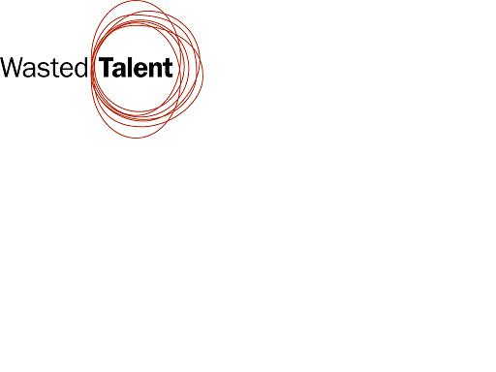

Rachel Mapplebeck on 020 7522 7880, 07811 456806, or RachelMapplebeck@whitechapel.org

