THOUGHT

A discussion between Agathe Jacquillat (FL@33), Angharad Lewis (curator of Public Address System), Duncan McAfee (The MM Press), Andrew Miller (The MM Press),
Tomi Vollauschek (FL@33), Harriet Warden (Henry Peacock Gallery), and Henry Peacock (Director, Henry Peacock Gallery)

AM – It would be good to develop a discussion amongst ourselves that will provide some insight into the exhibition, particularly design and typographical issues.

TV – The thing is, we do visual communication, and obviously typography is a part of it but we are not ‘typographers’. Some people in this exhibition are much more representative of typography than the two of us.

HP– Is that purely about background in that there are no typographers any more, that there are designers and graphic designers and typography has become part of these things and not a thing in itself?

AL – I think there are more visual communicators or graphic designers doing typography now, because the technologies for creating typefaces are there, and the technology has become more accessible. One of the things about this show is that we’ve got a real range of people from those you would regard as typographers and people like FL@33 who aren’t necessarily known as typographers. It shows the gamut from where typography is expressive to typography as one part of a larger thing.

HW (to FL@33) – So for this exhibition, you’ve been working on a Dalai Lama speech. Tell us about that.

AJ – The speech is all about peace and was given to the European Parliament just after the 11th of September. It’s about the danger of interdependence between nations and their responsibilities towards each other.

TV – Yeah, he talks about universal responsibility, like if we are less selfish we could avoid war. He makes these speeches once a year to promote his attitude towards non-violent struggle. He is an appealing personality.

HW – So what are the images of figures in this poster based on?

TV – We were playing with toy soldiers. Our original idea was to have an illustration of 70 – 80 toy soldiers from various centuries. We’ve selected three figures; the top one is a Neanderthal guy, and then there’s a contemporary one….

AJ – The three figures represent phases in human history. We are also representing the connections between them and the dangers.

TV – Yeah, I mean they could all kill each other - at the same time! There is a circular relationship between them. It goes back to this idea of universal responsibility. But we didn’t want to be too kitsch with this message because everybody knows it, it’s been repeated all over the place. We thought let’s show the whole speech. We were sure when we read the brief for this exhibition that quite a lot of people would focus on one word, or one sentence, but we wanted to show the whole speech somehow. We analysed the text and started highlighting the text with a marker.

AJ – Because the Dalai Lama is a really pure person, - he is just a simple monk - we wanted to treat the poster in the same way. By just highlighting with the marker important sentences, you get a poster that is really simple and straightforward.

TV – It’s quite difficult to read, by the end. At the beginning it’s easier but the lines get more interrupted as you read down the figures.

AM – How do you feel about that? Because from my point of view that looks really difficult to read, is that a problem?

AJ – It’s not a problem, the message is the image. If you are interested you can read the text.

HP – Is this a question of style over content? What I mean it is that if you can’t read it the content is lost, and then the only way to view it is through the style.

TV – Well once you get up close to it, it is easier to read and we have highlighted the important bits so it is easy to understand, its accessible in a way.

AM – It’s still less accessible than if the text was in a block, like from a page of a book. Your eye has to hop skip and jump around these visual interruptions.

AL – The way it is printed also puts some responsibility onto the viewer, they have to put something in to get something out, by engaging with it more closely.

HP – That has something to so with the idea of intimacy because you have to go right up to it and read it, in that way you have to work with it.

AM – If you were to get this text on a page of a book you would be able to read it more easily, but perhaps also discard it just as easily. Whereas with this, because you have to invest a certain effort to decipher the speech through this image, perhaps that effort will cement something a bit more solid in the viewer.

AL – It’s conceptual really, because it’s not just about immediate impact. That’s traditionally what a poster does.

AJ – Exactly that’s what we wanted to do!

TV – Yeah, we consider this poster to be pure and minimalistic. The technique at least is minimal.
We could have used flashy colours but it was never our aim to compete with other posters even though we are aware that if you use flashy colours and use one sentence you have a different impact – people go “wow!”

AM – Posters are in competition with each other in the real world, when they’re out on the streets - their job is to attract our attention above anything else, like when you see them pasted down the whole of a street.

AJ – We hope to be different, but at the same time that it will also grab your attention.

DM – It is almost like you are using the basic rules of typographical decision making that there is a sentence or a word that needs to be written in a way that fits the message the words are trying to give. You have used that rule literally but almost subverted it by doing exactly that to the point that the text has become almost illegible.

HW - Your approach to making a poster for a show must have been very different to the approach you would have to designing a poster for an outside setting.

AL – One interesting thing at the start of the show was that I was speaking to Erik Spiekermann, and he was saying that he wanted to do his poster in German and we were discussing how what language he did his poster in would affect his choice of typeface and things like that. His poster does that brilliantly. He’s using a Mark Twain speech about the German language and he’s set the German in one typeface and the English in another.

HP – It’s called “The Awful German Language”. It’s about Mark Twain going to this lecture. It’s half in German so he does his bad German in this beautiful black lettering. Then again it looks ugly! Its beautiful in the English and then it falls into German. As you read it’s almost telling you about typography, its makes you think about typography but it also makes you feel about typography.

AL – There are issues of readability and legibility there too, it’s all about the awkwardness of language, and making something visually awkward to reflect this. There is an element of that in Flat 33’s poster as well.

AM – The awkwardness of language occurs particularly when it is written down, for example text messaging has taken the place of flippant conversation, people always text you to say they can’t come and meet you because it is awkward to speak it but easy to write it. That sort of conflict of written text and the emotion that is lost by writing it down, is that trying to be reconciled in some way visually in your poster? It does seem that you have brought your own particular ideals and prejudices to the text.

TV – Subconsciously, probably! Whatever you do, as soon as you put it on paper, you’re going to be subjective.

AM – But does putting it in a more visual format alter those initial prejudices? I have to work a lot harder to read that poster. The thing that always comes back is the image that the text is forming.

AJ – When you illustrate a text with three sentences you don’t get the whole text. It’s just a resume. Here it’s similar in that you do get the whole text by seeing its visual resume; it’s the same kind of idea.

HP – It’s a bit like painting in that you look at something from thirty yards and then get so close that you smell the paint, and see how each brushstroke has been put on. It’s a dynamic - you need the visual aspect first, before you see how its been done.

DM – Why? Because you need to get into the state of mind of the person that made it, it‘s asking the viewer or reader to understand the process of making it.

TV – This is a very key question for visual communication. What has been passed down by the old masters is that visual communication has to be timeless, immediate and accessible. So if you want to create something that is accessible then you probably have to edit it in a way that is pre digested, which is subjective. That is the old fight that you’re not allowed to be subjective.

HP – That’s why the Bauhaus created its own kind of phraseology. Its actually important that people should look at these things in the same way, its about the same criteria. But we don’t look at painting or design like that and I think that’s a problem.

TV – This changed fifteen years ago - these days it is becoming more and more subjective and more and more artistic in a way. Graphic designers become artists without even trying, because we are trying to play with rules and trying to break them as much as possible. You might say that we are in a crisis at the moment. Are we artists? Can we do whatever we want? Or is it visual communication?

AJ – The boundaries are very blurred anyway.

AL – There is a difference between yourselves and someone like Erik Spiekermann because as a typographer he wants clarity and legibility to be the most important things, whereas you are very experimental.

TV – And maybe more emotional. I’ve been brainwashed in Germany for four years. For the first two years we were only allowed to make posters in one particular typeface. We didn’t even have computers. We were working in black and white only. It was much more refreshing to come to England and start breathing, to break all those rules.

DM – It works the other way around too. Traditionally artists had been about self expression and now you’ve got Saatchi values; very much about people illustrating ideas, playing to advertising ideals which are about the message and how effectively and immediately the message is put across. Art has become understood through the language of advertising. Our roles have become so intertwined that we’re almost doing the same thing. Fifty years ago we would probably have been fighting in here!

(laughter)

AL – This is what Tomi was talking about when he said there was an identity crisis in graphic design… It’s interesting for this show having graphic designers in the gallery. I personally find this a real conundrum that I wrestle with quite a lot. It’s showing typography to a different audience. Most people think of something very dry and inexpressive when they hear the word typography.

AM – That’s what I think about it! But what I have got from this discussion is that what you’re dealing with isn’t actually that far removed from what we’re dealing with and when the visitors come to the show they will hopefully leave with some similar sentiment. They can begin to understand these pieces of design because the visual language is not so far removed anymore.

TV – Well, in terms of classical typography and reading a book, the better it’s set, the less disturbed you will be while reading it. The better the typography, the more invisible it becomes.

HP – That’s a very modern idea, that you don’t notice the beauty of it.

AL – Typography’s function is to behave in the most appropriate way for the form that it’s in. I guess this show is about setting it free in a way, allowing designers to be more expressive. And that’s how you engage a wider audience to think more about how they look at design.

PROCESS

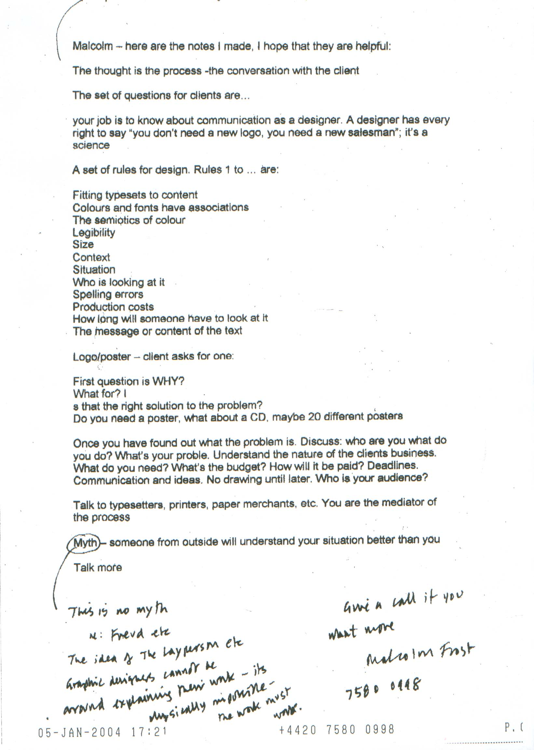

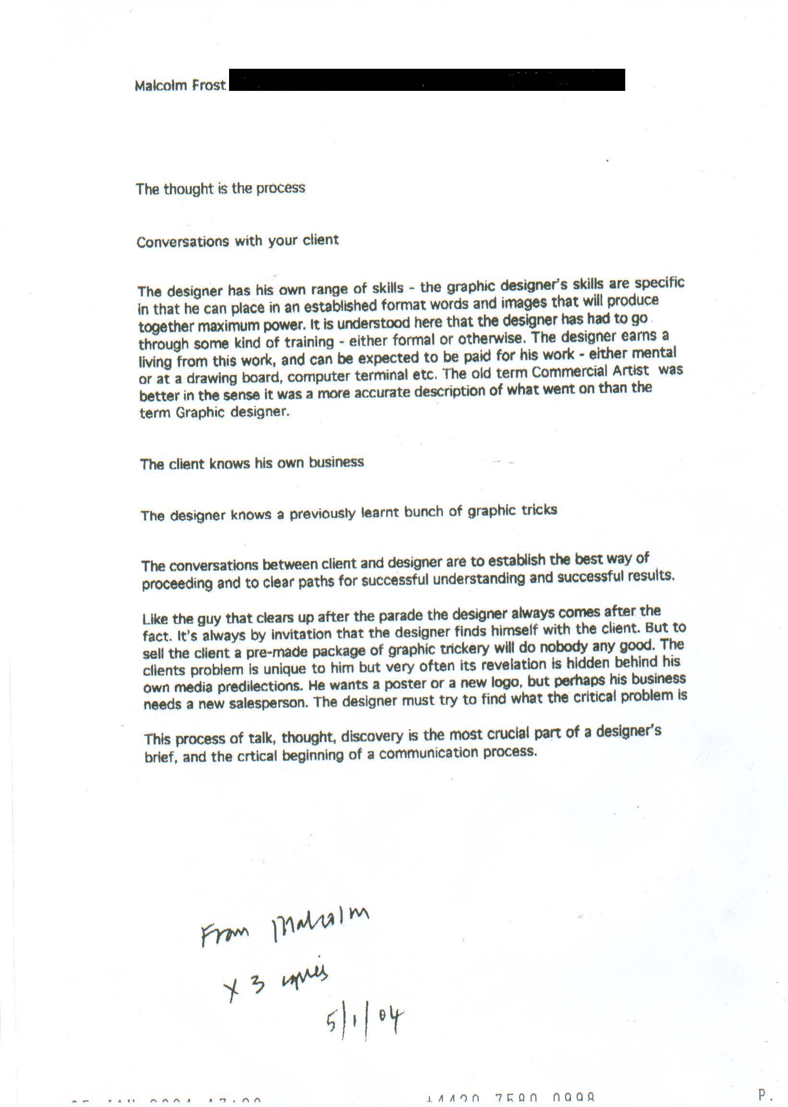

PLAY

