THOUGHT

Extracts from a conversation between Gereon Krebber, Duncan McAfee and Andrew Miller:

DM – One thing that you often talk about in your work is humour; a kind of juxtaposing or marrying of both the monumental and the ridiculous.

GK – Yes. This is what I sometimes say to describe the work; that it is ambiguous and working with monumental and comic appearance, these juxtapositions, these things that are actually quite opposite together in one piece creates this sort of humour because you don’t know what the thing is doing with you and you need certain relief.

DM – So you it seems that you are playing with the audience. How much are they part of that game or how much are you manipulating them?

GK – I think they are confronted with something, not really an object, some of the things I am doing are too big or too awkward to be an object, this new work is too big to fit into the gallery, I overdose the whole thing in the gallery, to blow it, to blow it with you, because you can’t really grasp it any longer you can’t read it any longer. You enter the space and you are almost stepping onto the piece; of course you couldn’t step on it, it’s nothing, it’s just Styrofoam, it’s too light, it’s really fragile. On the other hand the way I’m treating it, the way I’m causing the trouble, is that the thing is nearly disappearing, not only with the colour but with the size and the shape, you haven’t got a contrast or a distance to really shape the object in your mind. At the same time it’s silly, it reminds you of something, like a mouth, a reduced version of something that already exists in the world. But it’s not a symbol; every question you ask that piece, it says “well… could be?” when I’m making things that is what I try and trigger. I’m always thinking what does it say? Then I usually take the other path, so you are completely puzzled in the end. That makes them like red herrings. You have smoothness, this flow, and then the surface is crumbling.

DM – It’s almost like you’re wrestling with it, you’re denying its natural identity.

AM – Is that also related to scale?

GK – I’m very aware of scale. I have made work that is very small, so you have the impression you could swallow it, and I’ve made work that is actually too big for anything so you can’t transport it. You have something, which is there but has no reason to be there, which annoys you because it’s there.

DM – So are you playing with the conventions of the art object?

GK – yes, I find it more radical at the moment to produce objects. It is very common now to produce something that is not object based, but to confront somebody with the absurdity of something that has no reason to exist, I personally find that really obscene. Once you’ve entered that field you can ask why is Old Kent road covered with asphalt?

DM – Someone has made those decisions and they have become conventions. As those conventions arise within your work, you destroy them.

GK – Yes, I play with them. You can’t deny that they are there and they have certain meanings but you try to destroy them. You just turn them over. In my sculptural language I refer to modernist and ancient sculptures from the Stone Age. Looking at the shape of this new work, on a different scale you can imagine it being handled; you could hit something with it. at the same time I also want to make these things look like something coming out of the future. It’s quite a manneristic idea.

Returning to humour – I personally have no sense of humour. For someone who is not from Britain, I’ve always had problems understanding jokes. If somebody makes a joke, I tend to take that seriously. On the other hand I find things funny that are completely honest.

AM – This is a linguistic problem there that doesn’t exist in your art work because you can find something funny in the way something looks, because it’s outside of language.

GK – Well, it’s a play with this Modernist language of sculpture; it’s big, it’s shiny, it’s autonomous. It’s l’art pour l’art - art for art’s sake. It hasn’t been important for a while - when we grew up in the nineties there was video, there where contexts, people where asking for political reasons. I started with performance. I became unhappy with myself being in the work and tried to get rid of myself. I had a strong concern with sculpture when I started; I thought why don’t you just draw it? I still find with sculpture that it’s hard to see them because they have this sense of touch; they are there. On the other hand I was keen on having that shape.

AM – There’s still a sense of performance in the work in that you have to move around it and encounter it yourself as artist and viewer. Is this something that concerns you?

GK – That’s the reason why things are usually so big; you are not able to grasp them even if the shape is super simplistic.

AM – It’s where things begin to fall down and break apart that they lose their simplicity.

GK – Yes, the shapes become more complex; balance and non-balance.

AM – How then is there a way in for the viewer to begin to decipher the work?

CK – Usually the surface is attractive; it questions your expectations of what material could be. With the sticks for example you take a pvc tube like you would buy a B&Q and then you start wrapping gaffer tap around and around and then incorparate small items that find on the street, so it has quite an articulated shape finally wrapped in cling film. I wanted to do something where the appearance of the thing was minimised in terms of extension so I had this stretched Brancusi going on. But then I ask myself what’s going on inside.

DM – Looking at these sticks I want to work out what the objects beneath the surface are. You get the imprints of the objects and then mentally unwrap it, undoing the process that you’ve done. It’s like a game of fencing that extends into the experience of encountering it as well.

GK – You see the material and you ask what it is doing to you and then you have a certain part in the sculpture itself. What is it? – this question is crucial. There is something in these sculptures that suggest they could be used like a tool or a weapon, but what can you use it for? How are you supposed to use it?

DM – I’m getting some sense of the political element of your activity. Its almost like the work is a catalyst which encourages the viewer to be more thoughtful. Giving them the tools to share this way of questioning.

GK – I’m not giving a message that you can read. All these pieces are too autistic, they block your way they say ‘I’m on my own, I don’t care whether you are there or not, I’m not telling you anything’. That makes it really hard to make contact with them. You’re not supposed to be there because there’s not enough space for you. It is somehow ignoring you. In a way they are too perverted,

DM – Yes well cling film is a very fetishistic material!

GK – But its not like I’m using rubber, that’s too loaded, it’s hard to make it into something new, it has too many associations already. I’ve never used bronze or steel, they’re heavy and industrial cultural material

AM – You’re materials seem to operate on a smaller scale.

GK – They are more direct and when you use industrial materials you lose that quality

DM – There is an industrial element to these works though in the way you have to constantly build up layer upon layer

GK – It’s like when I try and get clay to look like metal to create an illusion so the viewer doesn’t know what they’re looking at so that they don’t know how to deal with it. I had this idea of declaring war on the viewer. Literally saying “hey! I want to kill you”

AM – I’m interested in the relationship between the work and the viewer. These are labour intensive processes that you go through and then you have this idea of declaring war on the viewer this seems very aggressive.

GK – Yes! Very masculine.

AM – But what are you expecting from the viewer in terms of the effort they need to invest in order to begin to understand the work. When someone experiences these confrontational works what would be the ideal reaction.

GK – It’s not that simple. On the one hand you have this masculine energy on the other there is something else going on they seem to disappear, turn away they even have a certain sweetness or melancholy. It took me two years to get this balance right. The piece I did for the Jerwood is actually quite cuddly, you want to hug it, but it will cut your dick off!

(Laughter)

DM – But just going back, what is the ideal viewer, walking away from your work, thinking?

GK – It’s like a big question mark, a mixture of irritation and discomfort. A sense that you can’t take anything for granted. It’s about being there and having a problem. If you get that that’s good!

DM – Well the next question has to be why? Why do you want to make people feel like this?

GK – I think it is necessary to cause people problems. That’s my mission and it’s quite awkward to have that mission. I actually think you deserve it as it gives you a certain sense of relief afterwards. It clarifies certain things it gives you a sense of knowledge in its own right which you can’t encounter somewhere else. And that’s the reason why I have spent my entire life in this dodgy studio … just doing that.

DM – You sometimes talk about the viewer in a kind of contemptuous way but them you also offer them knowledge through these experiences of your objects. How much do you care about the viewer?

GK – I have to say I don’t care a lot about the viewer. I just care about the kind of experience you should have.

DM – Are you concerned as to whether they get that experience or not?
GK – No, actually not. Perhaps you’re right and I’m doing for myself and I need an excuse for doing it for myself. I don’t know. It’s just important that this kind of thing exists, I do believe that.

DM – It’s a kind of faith

GK – Yes it should be.

AM – But how does the gallery as a space operate in all of this? In terms of the new work that takes up the whole gallery the viewer may feel they are imposing themselves onto the work’s space, or maybe that happens because the work is in a gallery, how differently does this work with the Jerwood piece which is outdoors on a public space.

GK – Yes. It works differently it looks like it has been dropped from outer space and is now doing what ever it likes. It is ignoring everything again! You might call it site specific but I am more site-ignoring.

DM – You’re a Punk!

GK – No! Perhaps a bit of Techno!

(Laughter)

GK – Actually I was really into Techno but not any longer because I don’t listen to music. I find it too affective I can’t deal with that any longer. A couple of years ago I stopped going to the cinema and listening to music and I stopped drinking and eating meat, so I had several cuts. Music was a real problem because it was so overwhelming, you get emotions just by listening and I had to stop that.

AM – But doesn’t any of that threaten to come in the art work? Like being seduced by the surface.

GK – It’s just a question of control. It’s this moment of getting out of control that I’m doing in my sculptures.

AM – They are like rule breakers. In the sticks for example you establish a structure and then there are these growths that are denying a general trend to go straight and up, they are breaking the ‘upright’ control. Like breaking the rules to a game or some form of play.

GK – Actually my girlfriend says when I go to the studio that I’m going to play! And in fact my treatment of materials is invented by playing with them.

DM – The game evolves as it goes along, you make up a new rule that throws everything else out.

GK – Yes I enjoy that, but its also the reason why I can’t play games. I have no sense for them, I have no games at home. My life sounds really miserable!

(Laughter)

DM – I’m imagining you removing stuff to the point where it is just you in a white space and you have become one of your monumental but ridiculous, funny but serious, sculptures.

GK – It could well be that the kind of reductions in my life, living in 12 square metres with my girlfriend, just travelling by bike and nothing else, that that could be in the sculpture in a translated sense.

DM – That comes back to the element of performance. It seems it is still rooted within your work somewhere, whether it be your physical interaction with your work or a broader attitude to living.

GK – Yes…

PROCESS

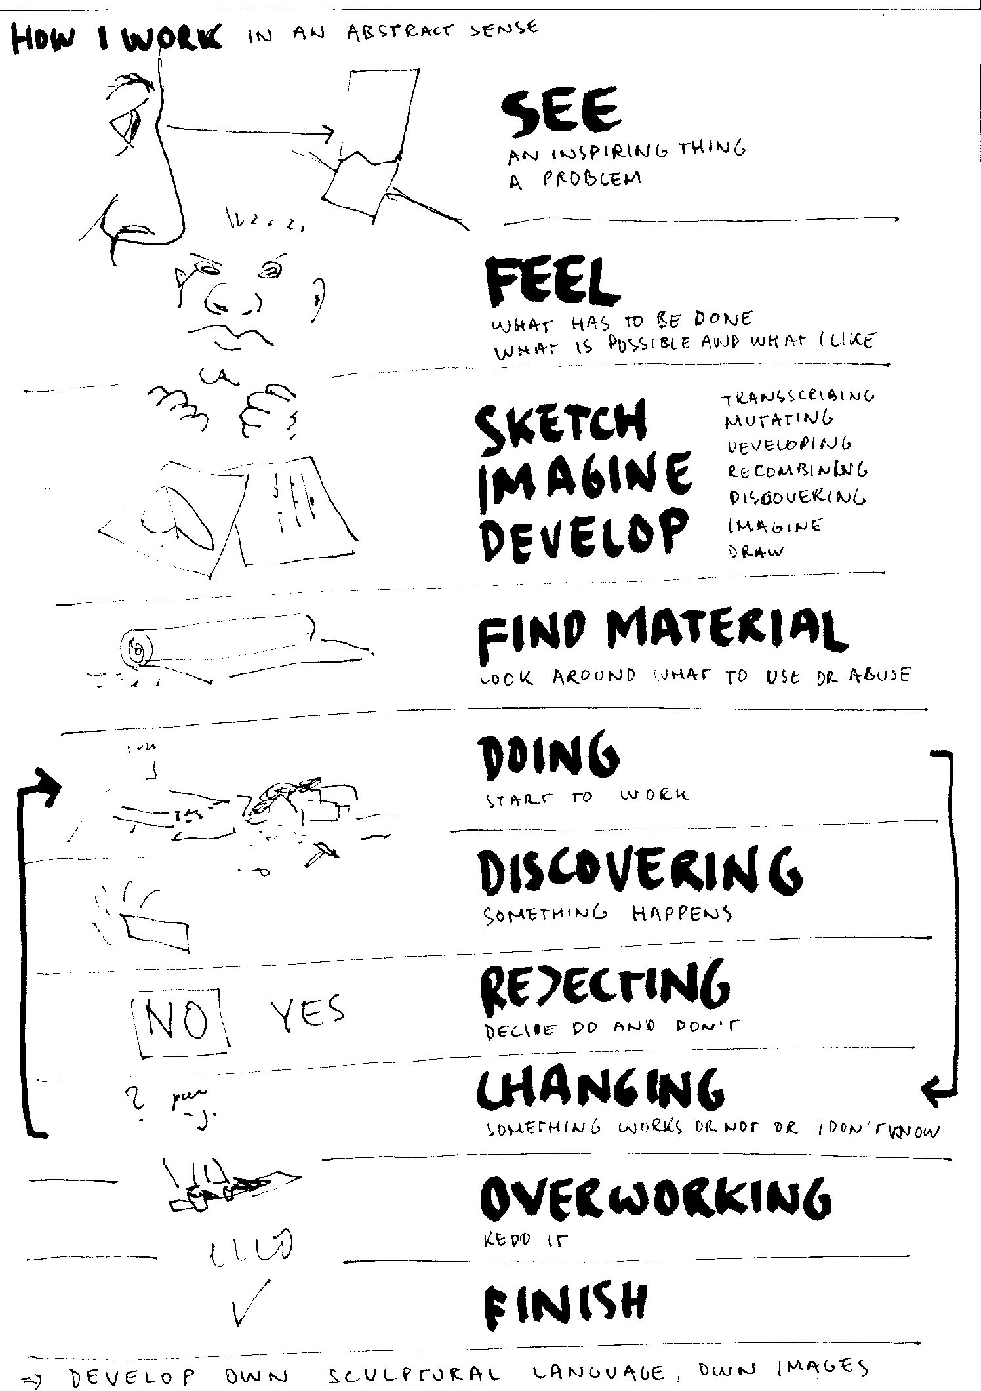

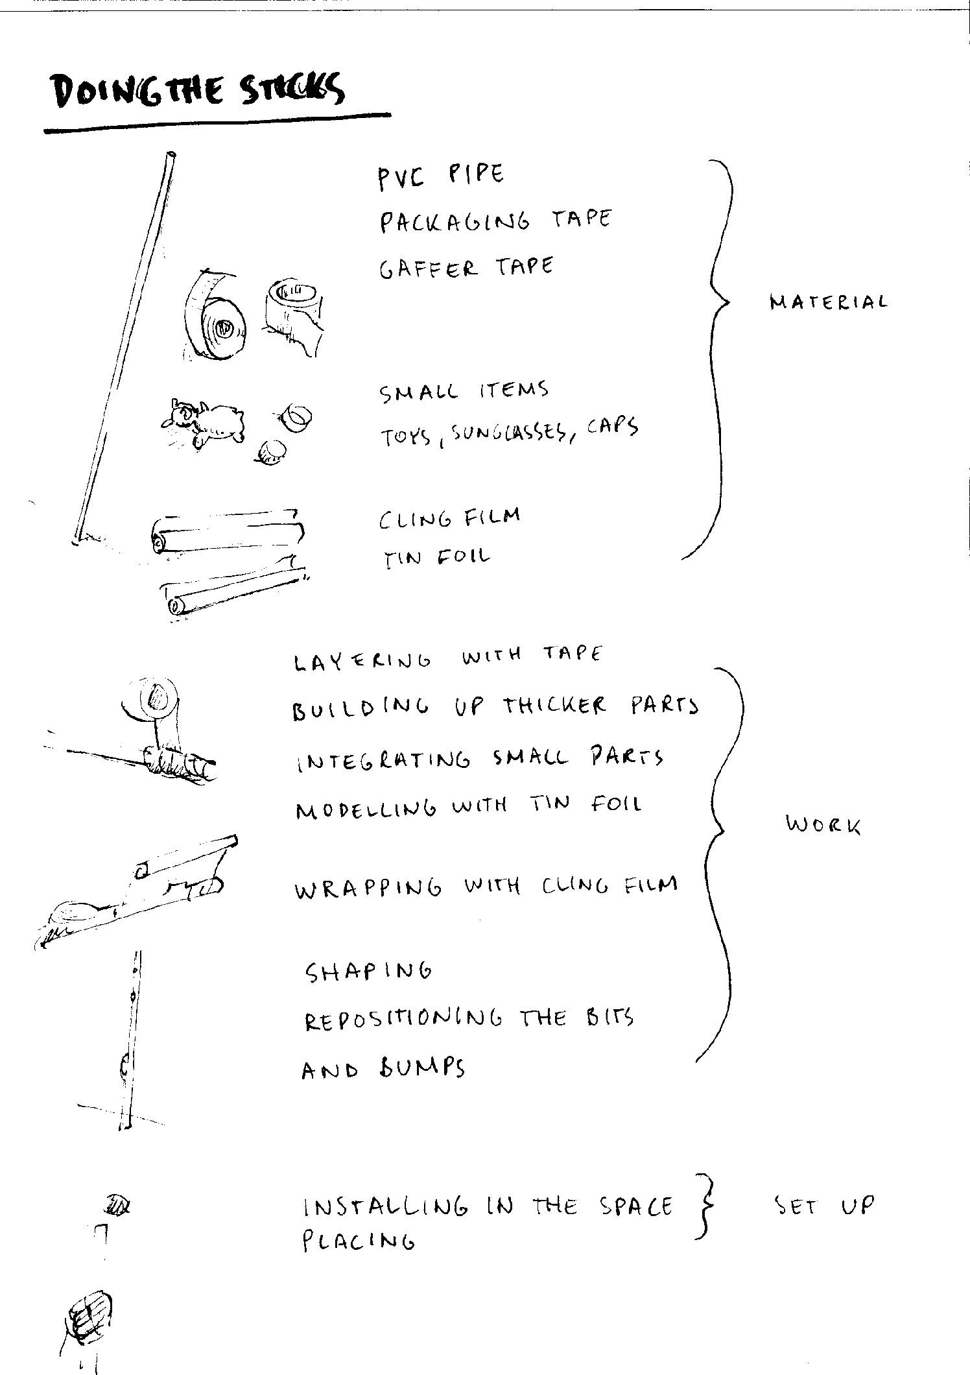

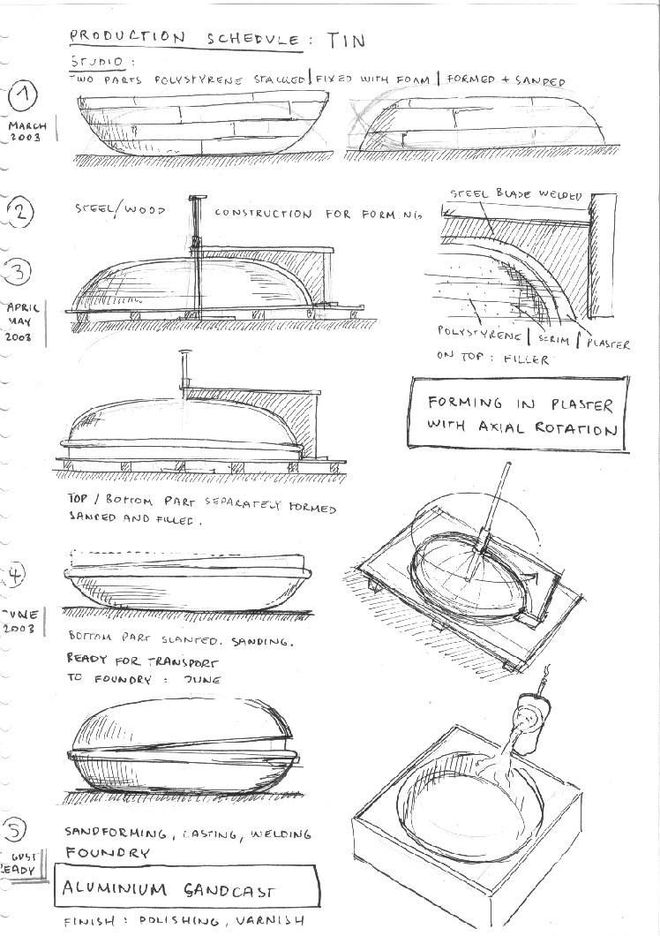

PLAY

